

Unified Experience Tracker
Requirements Document

www.1rivet.com
Washington, D.C. | New York | Toronto | India
Table of Contents
1 Business Requirements: 3
2 System Requirements: 3
2.1 Client Management 3
2.2 Campaigns Management 3
2.3 Events Management 3
2.4 QR Code Management 4
2.5 Surveys: 4
2.6 Post-Event Metrics: 4
3 Functional Requirements: 4
3.1 Create/Update Campaign (as per Brandscopic) Form: 4
3.2 List of Campaigns (As per Brandscopic): 6
3.3 Create/Update Events: 7
3.4 List of Events: 8
3.5 Post-Event Metrics (Reverse Sync): 9
3.6 Add URL for QR Code: 10
3.7 Listing Screen of QR Codes: 10
3.8 Associate Event Details with QR Code: 10
4 Mock-ups: 12
4.1 Campaign Listing Screen: 12
4.2 Create Campaign (as per Brandscopic) Form: 12
4.3 Edit Campaign (as per Brandscopic) form: 13
4.4 Event Listing screen: 13
4.5 Create Events: Default Screen 14
4.6 Create Event: Single Day 15
4.7 Create Event: Multi Day 15
4.8 Additional Event Details from the listing screen: 16
4.9 QR Codes Listing screen: 16
4.10 Add URL for QR Code: 17
4.11 Associate Campaign and Event Date-time: 17
4.12 Edit Campaign and Event Date-time: 18
6 UET Process Flow: 19
7 Data Dictionary: 20

1 Business Requirements:
- Establish a unified experience tracker (UET) where events can be managed centrally. This solution will allow a streamlined process of data aggregation and provide a centralized location for all the connected data.
- External system integration will be covered for campaigns and events via Brandscopic, QR code via QR Tiger and Surveys via Qualtrics Surveys.
  - Events created or updated in UET will reflect in Brandscopic. If Brandscopic has any updates, data will be reverse synchronised to UET. Both systems will be in Sync.
  - URLs will be assigned for each event, which will be associated with QR codes. This will be generated by QR Tiger API.
  - Surveys will be managed by Qualtrics Surveys. UET will store only the IDs of surveys if surveys are created for any event.

2 System Requirements:

2.1 Client Management
- Every campaign is created for a client.
- From a system perspective, the client is used to physically separate data collected from various external systems.
- There are two different roles defined in the UET application. One is an admin role which will have access to all the client information and the other will be a user-specific role which will have access to assigned client’s information only.
- Configuration of each Client will be done manually and will require Infrastructure assistance for creating Client specific DB tenants.
- For each client, the admin user can configure which external system should be integrated for the client.
  - For release 1, the system will only support 3 external systems (Brandscopic, Qualtrics Surveys, and QR Tiger)
- Client data will be predefined and stored in the UET database.

2.2 Campaigns Management
- UET users will be able to create, update and delete campaigns from UET Portal for any Client.
- Users should be able to associate Master Program, Name, type, region, logo, and status while creating the campaign.
- Brandscopic does not provide Campaign creation API, so the user will have to manually create it in Brandscopic.
  - UET users will be able to manually associate the Brandscopic Campaigns in the UET system.

2.3 Events Management
- UET Users will be able to create, update and delete events to any campaign in UET Portal.
  - For release 1, every event operation (create, update, delete) will be reflected in Brandscopic.
  - This is controlled through a configuration at the Client level.
- Users will be able to add a name, date, time, venue type and address while creating the event.

2.4 QR Code Management
- UET Users will be able to create QR codes in UET using URLs via integration with QR Tiger. The UET database will store QR Tiger ID, URL, and associated QR Code.
- Users will be able to associate multiple QR codes with each event.
- Users will be able to associate the same QR code to multiple events, however, only one event should be active with the same QR code.

2.5 Surveys:
- Surveys will be managed by Qualtrics Surveys. UET will only store the IDs of surveys if surveys are created for a particular event.
- Users will be able to manually map surveys with the event and only one survey can be associated with one event.
  - Importing survey responses from Qualtrics will be out of scope.

2.6 Post-Event Metrics:
- Post-event metrics will be synced from Brandscopic to the UET database at a predefined schedule. The following attributes will be synced from Brandscopic:
  - Impression, Photo, interactions
  - Custom Fields
- The count of QR code scans of each event should be synced to the UET database from QR Tiger after the event is over.
- Apart from the predefined schedule, users will be able to perform a sync operation from the event listing screen. Users will have the choice between syncing a specific event, or all the events associated with a campaign.

3 Functional Requirements:

3.1 Create/Update Campaign (as per Brandscopic) Form:
- Users will be able to add, edit and delete campaigns.
  - Users can delete campaigns if there are no events associated with the campaign.
- Users will be able to map campaigns of UET and Brandscopic manually.
  - For now, as campaigns API is not available in Brandscopic, manual mapping should be done, and data should be stored in the UET database.
- Below given are the details required to create campaigns.
- Master Program
Required/Optional | Required
Type | Searchable Drop-down
Note | The user cannot update this field.
- Name
Required/Optional | Required
Type | Text Field
Note | The user can update this field.
- Client
Required/Optional | Required
Type | Searchable Drop-down
Selection | Single-Selection
Note | The user cannot update this field.  Data will be fetched from the database and new clients will be added to the database directly.
- Type
Required/Optional | Required
Type | Searchable Drop-down
Selection | Single-Selection
Note | The user cannot update this field.
- Region
Required/Optional | Optional
Type | Searchable Drop-down
Selection | Single-Selection
Note | The user cannot update this field.
- Logo
Required/Optional | Optional
Note | If not attached, initial characters will be displayed.  Users can update the logo.
- Status
Required/Optional | Required
Type | Searchable Drop-down
Selection | Single-Selection
Note | Default status ‘New’ will be selected.
  - List of status:
    - New: By default, the campaign will be in this state. If all the events are inactive, then the user will be able to change this status.
    - In-Progress: A minimum of one event would be active/confirmed then the user will be able to change this status.
    - Completed: When an event is completed, the user will be able to change this status.
- Save: By clicking on this button, data will be saved with a unique ID and the user will be routed to the landing screen.
  - Validation:
    - The user should pass all the validations and after that, this button will be enabled.
    - Data will be saved, and the toaster message will be displayed as "Data saved successfully."
    - For Edit Scenario: the toaster message will be displayed as “Data updated successfully.”
- Cancel: For not submitting data and going back to the listing screen, the user will click on this button.
  - Validation:
    - After clicking on it, a confirmation pop-up will be displayed with a message (Are you sure you want to cancel?) with two more buttons YES and NO.
      - YES button: The user will be moved to the listing screen, the pop-up is closed, and all data is discarded.
      - NO button: The user will stay on the same screen.
  - NOTE: If there are any unsaved changes then only the confirmation popup will be displayed.

3.2 List of Campaigns (As per Brandscopic):
- Campaigns should be set up at UET and sent to Brandscopic via API.
- Users can create a new campaign by clicking on the ‘+ New Campaign’ button and can view all the campaigns on screen with other details which are given below.
- Search: The user will enter text, number, and special characters in the search box. It will be a global search, meaning all fields in this screen will be included in the results.
- Below Given are the details that will be displayed on the Campaign listing screen.
- ID: The user can view the Ids of the UET system.
- Campaigns: The user can view the Campaigns name.
- Client: The user can view the client’s name.
- Status: Maintain status based on events completion.
  - For now, the status will be managed manually.
  - There will be three statuses available for campaigns.
    - New
    - In-Progress
    - Completed
  - Users can update their status from this screen via the status drop-down.
- Region: The user can view the regions associated with Campaign.
- Event type: The user can view the type of Campaign.
- Master Program: The user can view the master program associated with it.
- Updated By: The user can view the updated-by name who updated/created the Campaign. This will include the initial user who creates the Campaign but will include being updated with the latest user info when the Campaign is modified.
- Updated Date: The user can view the Updated-date when the user updated/created the Campaign. This will include the initially created date but will change when the Campaign is modified with the most recent date.
- Actions:
  - Edit: The user can edit the campaign details.
    - Once the status is ‘completed’, the edit feature will be disabled.
  - Delete: The user can delete campaigns that are in the new state.

3.3 Create/Update Events:
- Users can create, update and delete events for single/multiple days.
  - If the event is in a Proposed, Tentative or Cancelled state, then only the user can delete it.
- Given below are the fields needed for creating/updating events:
- Event Date
Required/Optional | Required
Type | Date-picker
Note | Users can select multiple dates.  According to that selection, time will be added to individual dates.
- Start time: The user can select the start time for the event and update also for valid criteria.
Required/Optional | Required
Type | Time-picker
- End Time: The user can select the end time for the event and update also for valid criteria.
Required/Optional | Required
Type | Time-picker
- Venue Name: The user can add/update the venue name where the event has been scheduled.
Required/Optional | Required
Type | Text Field
- Venue Type: The user can add/update the venue type.
Required/Optional | Required
Type | Searchable Drop-down
Selection | Single-Selection
- Address line
Required/Optional | Optional
Type | Text Field
- City
Required/Optional | Optional
Type | Searchable Drop-down
Selection | Single-Selection
- State
Required/Optional | Required
Type | Searchable Drop-down
- Zip Code
Required/Optional | Optional
Type | Text Field
- Do we need to validate the zip code with city and state with external API?
- Do we need country selection or by default that will be for the USA?
- Note: If the event status is ‘Confirmed’ then the user cannot update the details.
- Multiday Events: Add different time slots for all the event dates.
- Save: By clicking on this button data will be saved with a unique ID and the user will be moved to the landing screen.
  - Validation:
    - The user should pass all the validations and after that button will be enabled.
    - Data will be saved, and the toaster message will be displayed as "Data saved successfully."
    - For Edit Scenario: the toaster message will be displayed as “Data updated successfully.”
- Cancel: For not submitting data and going back to the listing screen, the user will click on this button.
  - Validation:
    - After clicking on it, a confirmation pop-up will be displayed with a message (Are you sure you want to cancel?) with two more buttons YES and NO.
      - YES button: The user will be moved to the listing screen, the pop-up is closed, and all data is discarded.
      - NO button: The user will stay on the same screen.
- NOTE: If there are any unsaved changes then only the confirmation popup will open.

3.4 List of Events:
- Events will be set up at UET and sent to Brandscopic via API. We will then receive IDs using GET API for any data that was established there. Post-event metrics will be used to update data here for the same ID against all the third-party applications.
- From this, the user will be able to identify clients, event types, dates, and even locations.
- Users can view the list of events and by clicking on “+ New Event” they can create new events.
- Search: The user will enter text, number, and special characters in the search box. It will be a global search, meaning all fields in this screen will be included in the results.
- Sort: The user can perform sorting on all the columns.
  - Default sorting will be on Event Date.
- ID: Ids will be displayed on this system
- Event Venue: Users can view the event venue.
  - Display the Venue name and on hover display the full address.
- City: Users can view the city name where this event has been scheduled.
- Event Date: Users can view the event dates which can be single or multiple.
- Start Time: Users can view the event start time which is associated with the relevant date.
  - display date and time
- End Time: Users can view the event end time which is associated with the relevant date.
  - display date and time
- Status: Users can view the status of events.
Proposed | A proposal for the event was made.
Tentative | the decision has not yet been made
Confirmed | The clients gave their approval for the event.
Cancelled | The event was postponed and then cancelled.
Active | The event began.
Inactive | The event has not yet begun
Completed | The event was finished.
Question | Should we follow these all statuses?
- Updated By: The user can view the updated-by name who updated/created the event. This will include the initial user who creates the event but will include being updated with the latest user info when the event is modified.
- Updated Date: The user can view the Updated-date when the user updated/created the event. This will include the initially created date but will change when the event is modified with the most recent date.

3.5 Post-Event Metrics (Reverse Sync):
- On the event listing screen, users will be able to view data of the sync process and will be able to perform the sync process manually.
- A user can only conduct one operation at a time. Individual sync buttons get disabled if the user clicks the sync button to sync all of the events, and the opposite is true for individual events.
- Every morning at 7:00 AM, an auto-scheduler will be set up to resync data from Brandscopic to UET.
- There will be data displayed on the screen in overlay form from the event listing screen where all the IDs will be there including Brandscopic ID, QR Tiger ID, and Qualtrics ID with the status of this data hub. These IDs will be useful while searching data in the database of relevant systems.
  - Completed: The sync process is completed.
  - In-Progress: The sync process is in progress.
- This sync icon button will then display the following statuses:
  - Yellow - Process has begun or the button just clicked.
  - Green - Data successfully synchronized with the system.
  - Black - There are no background processes active. The user can proceed by clicking, or the scheduler can run those data at a specific time.
  - The status of the button and the icon for each event will change to yellow when the synchronization of data is ongoing.
  - After the data has successfully synchronized with the system, the status will be green for 3 minutes. After then, it will be changed to black since Brandscopic, QR Tiger and Qualtrics may have recently updated data that may not have synchronized with this page.

3.6 Add URL for QR Code:
- Users should be able to add URLs with QR code names and statuses from the listing screen by clicking on ‘+New QR Code’.
  - QR Code Name: Users should be able to add a QR Code name.
Required/Optional | Required
Type | Text Field
  - URL: Users should be able to add a URL for a particular QR Code.
Required/Optional | Required
Type | Text Field
  - Status: Users should be able to select status, which will indicate whether the URL is active or inactive. Based on this status, this same URL will be used in different events.
Required/Optional | Required
Type | Text Field
Selection | Single-Selection

3.7 Listing Screen of QR Codes:
- Users will be able to view QR code details on the listing screen.
  - QR Code: Users can view the QR Code.
  - URL: Users can view the URL associated with the QR Code.
  - Status: Users can view the status- Active/Inactive.
  - Search: The user will enter text, number, and special characters in the search box. It will be a global search, meaning all fields in this screen will be included in the results.
  - Actions:
    - Edit: Users will be able to edit data.
    - Delete: Users will be able to delete a record.

3.8 Associate Event Details with QR Code:
- Users will be able to associate Campaign and event details with the QR Code.
  - Campaign: Users can select Campaign from the list.
Required/Optional | Required
Type | Drop-down
Selection | Single-Select
  - Event Date & Time: Users can select Event Date & Time and data will be filtered out based on Campaign selected.
Required/Optional | Required
Type | Drop-down
Selection | Single-Select
Note | All the confirmed events data will be fetched here.
  - URL: Users can select a URL which will be then associated with the event.
Required/Optional | Required
Type | Drop-down
Selection | Single-Select

  - Note:
    - Users can select multiple events of each campaign to associate URLs.
    - Users can associate the same URL with multiple events.
      - Validation: All the event dates & times should be different then only users can associate the same URL.

4 Mock-ups:

4.1 Campaign Listing Screen:
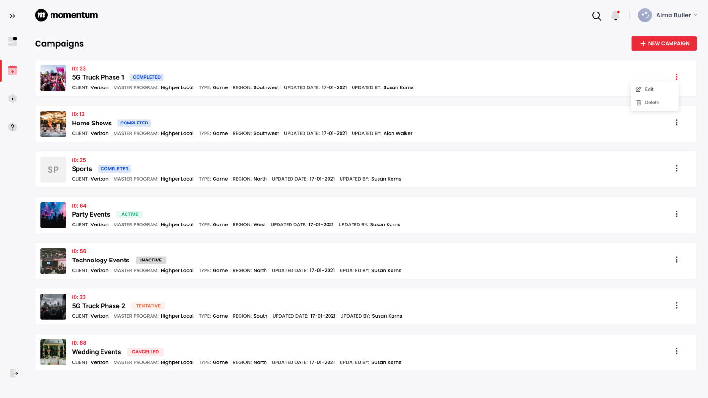

4.2 Create Campaign (as per Brandscopic) Form:
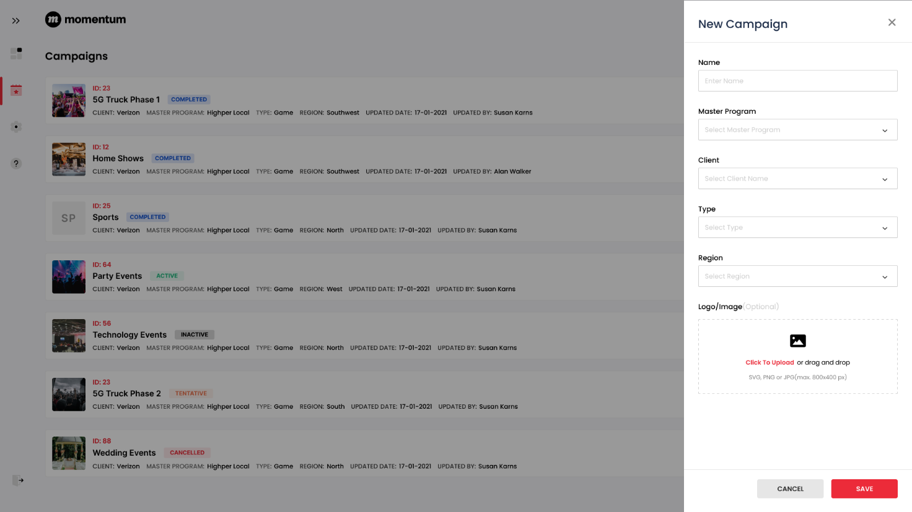

4.3 Edit Campaign (as per Brandscopic) form:
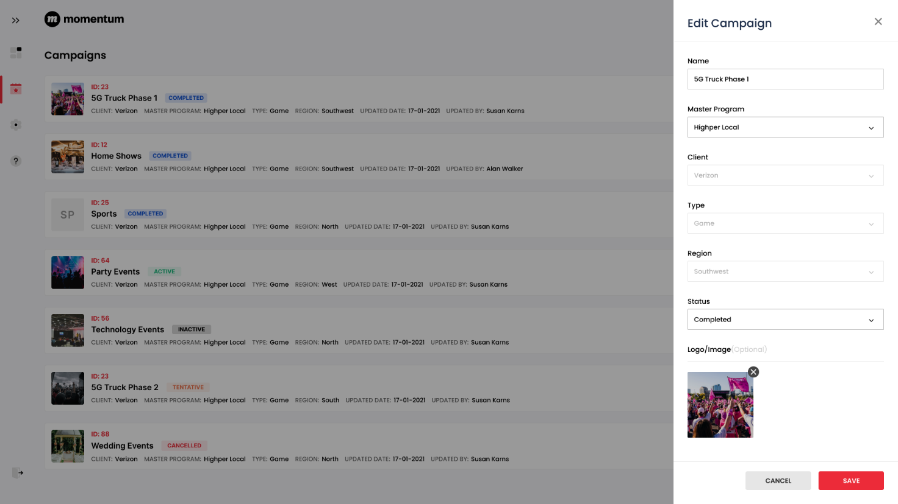

4.4 Event Listing screen:
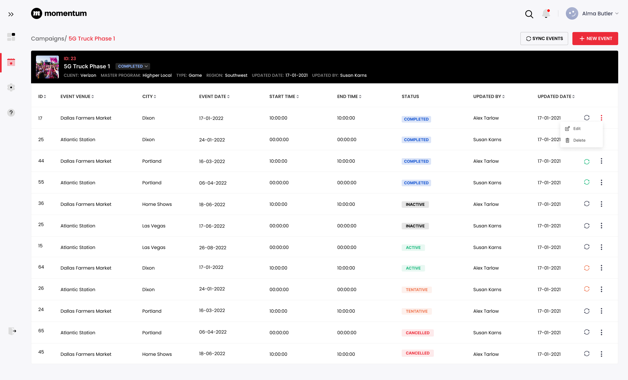

4.5 Create Events: Default Screen
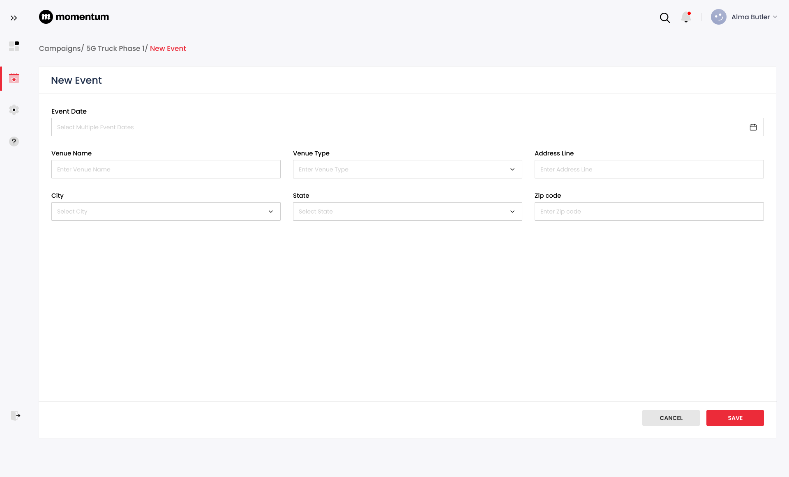

4.6 Create Event: Single Day
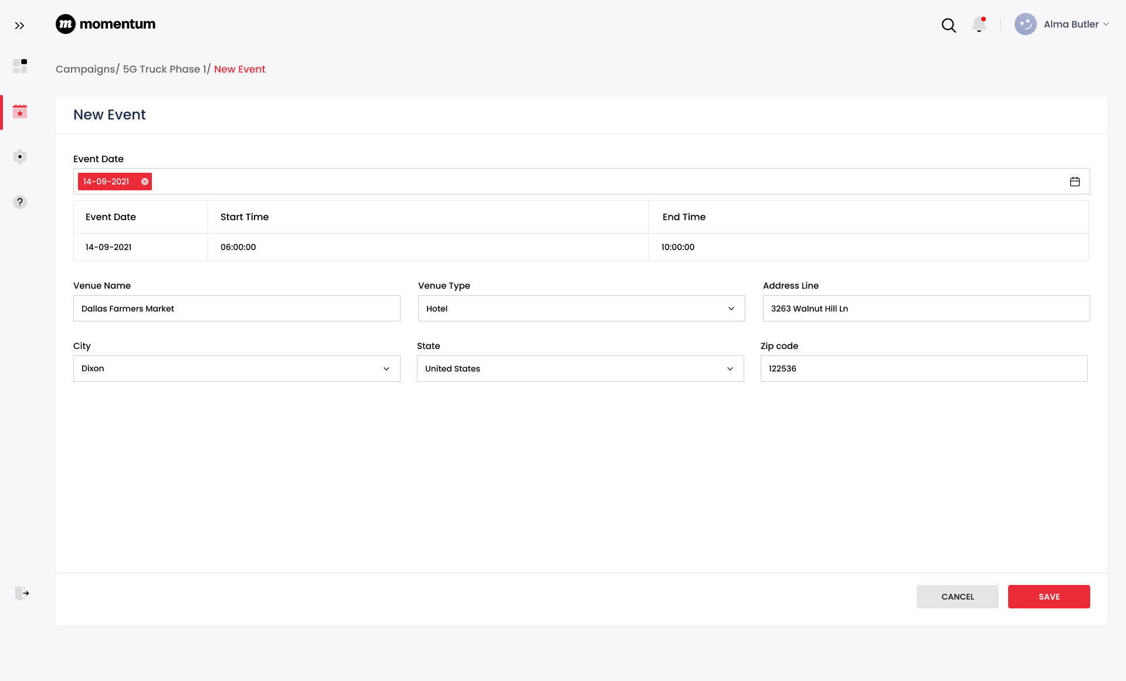

4.7 Create Event: Multi Day
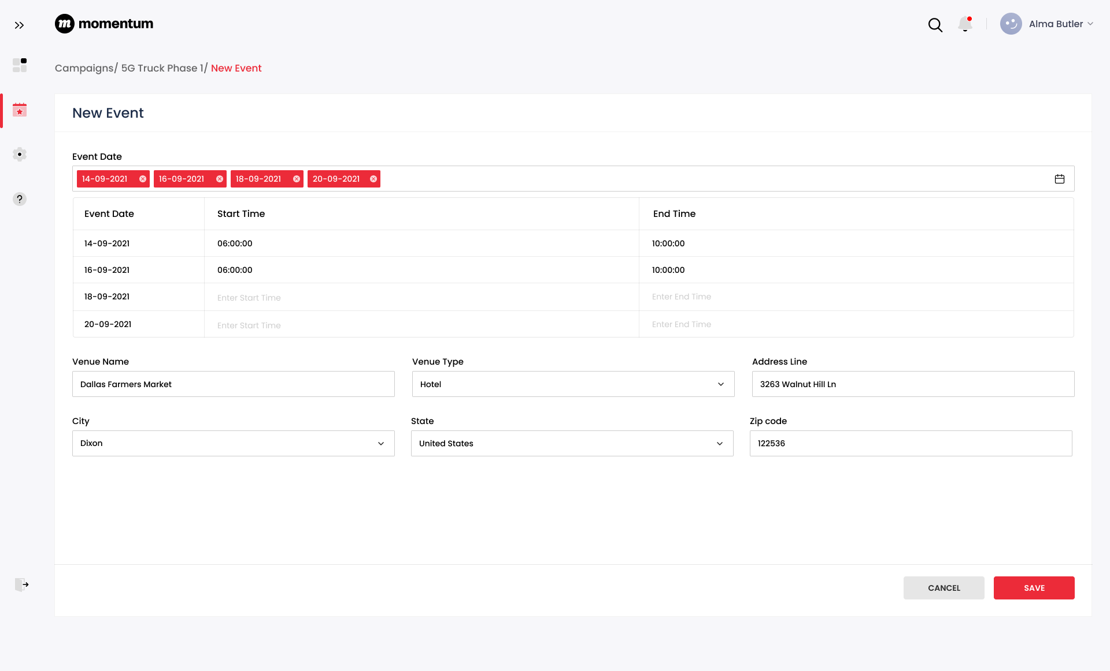

4.8 Additional Event Details from the listing screen:
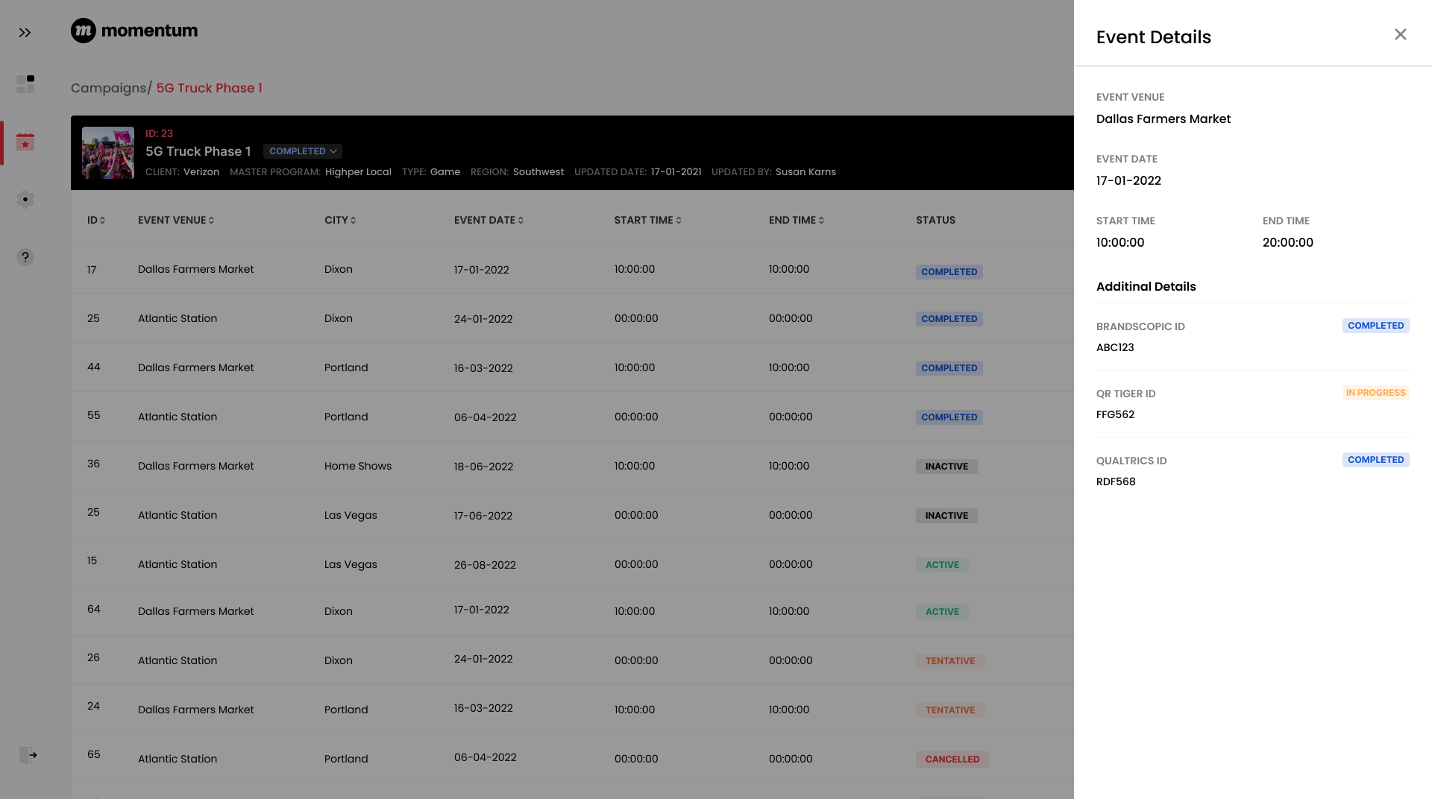

4.9 QR Codes Listing screen:
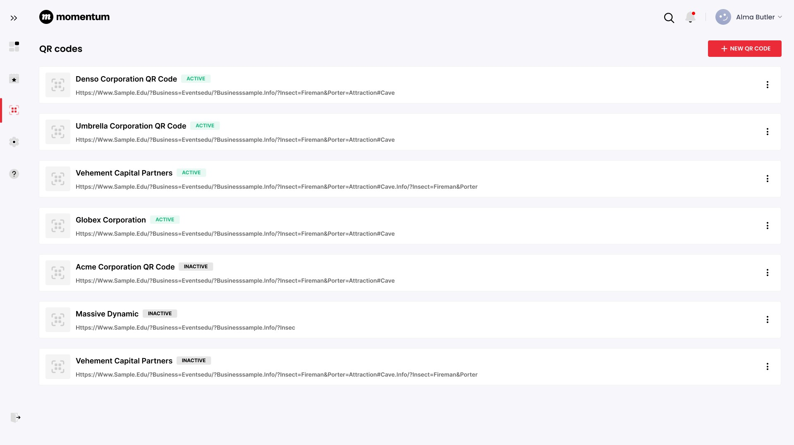

4.10 Add URL for QR Code:
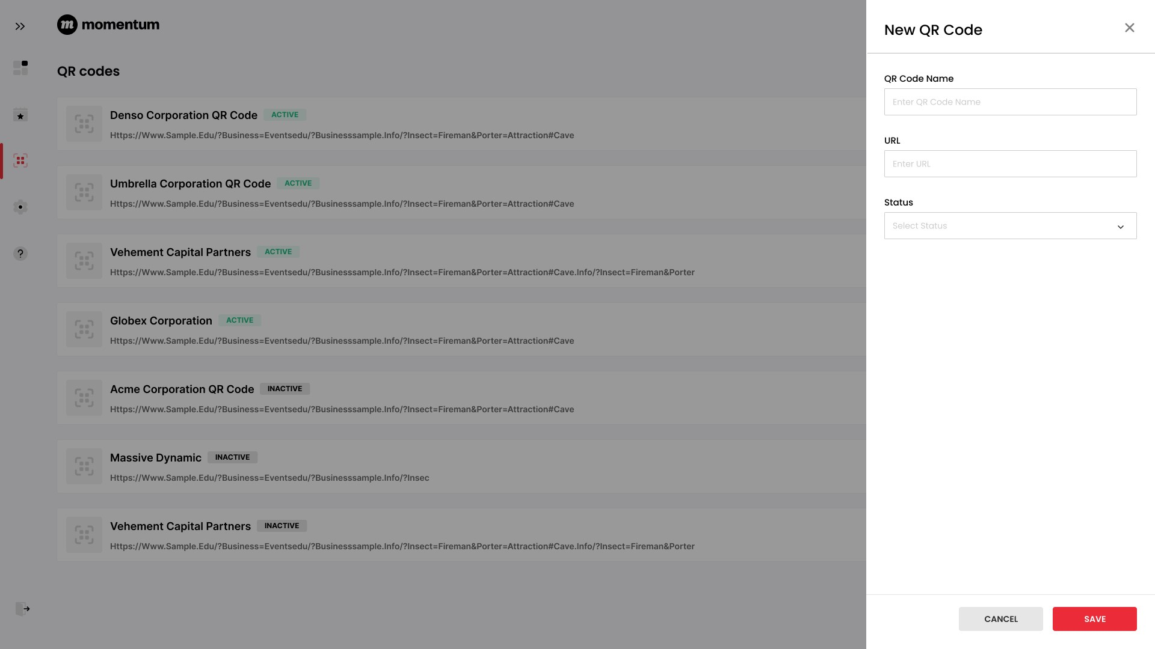

4.11 Associate Campaign and Event Date-time:
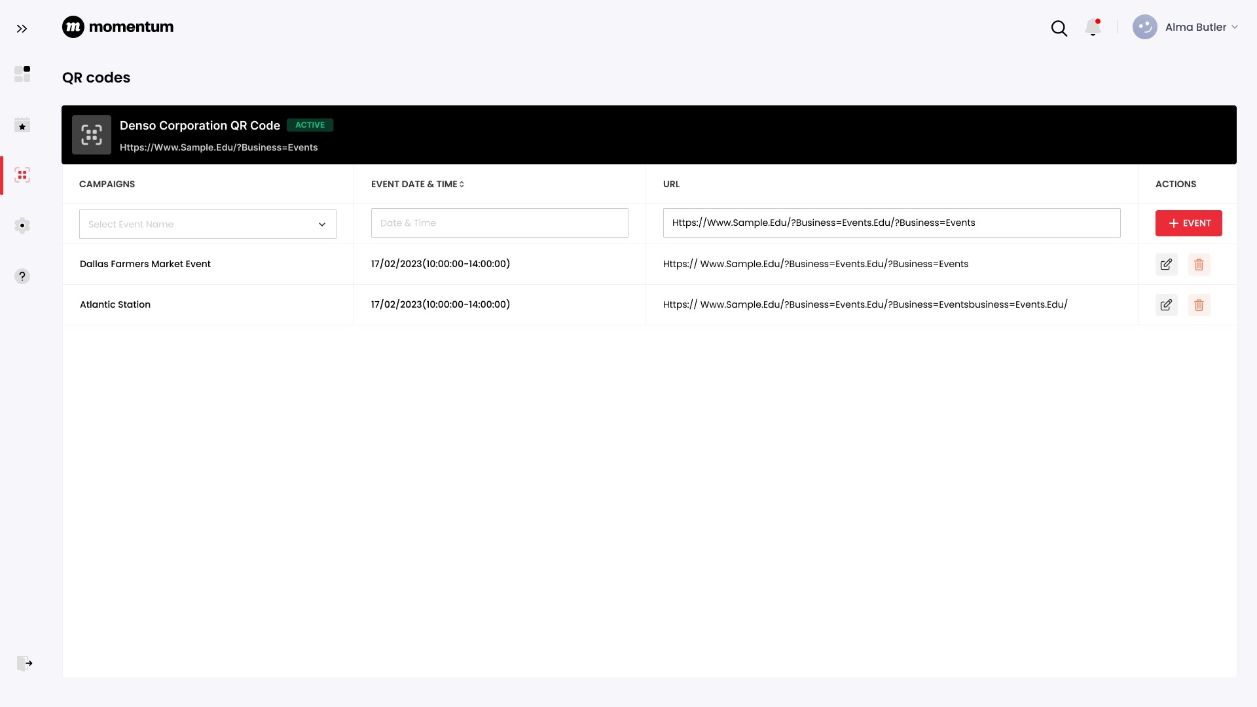

4.12 Edit Campaign and Event Date-time:
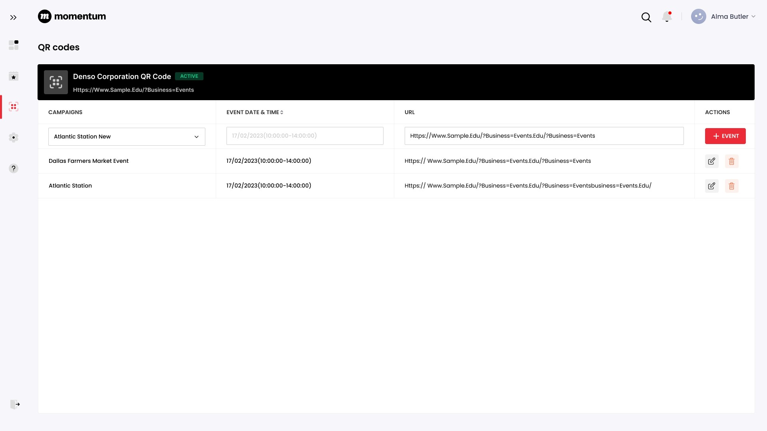

6 UET Process Flow:
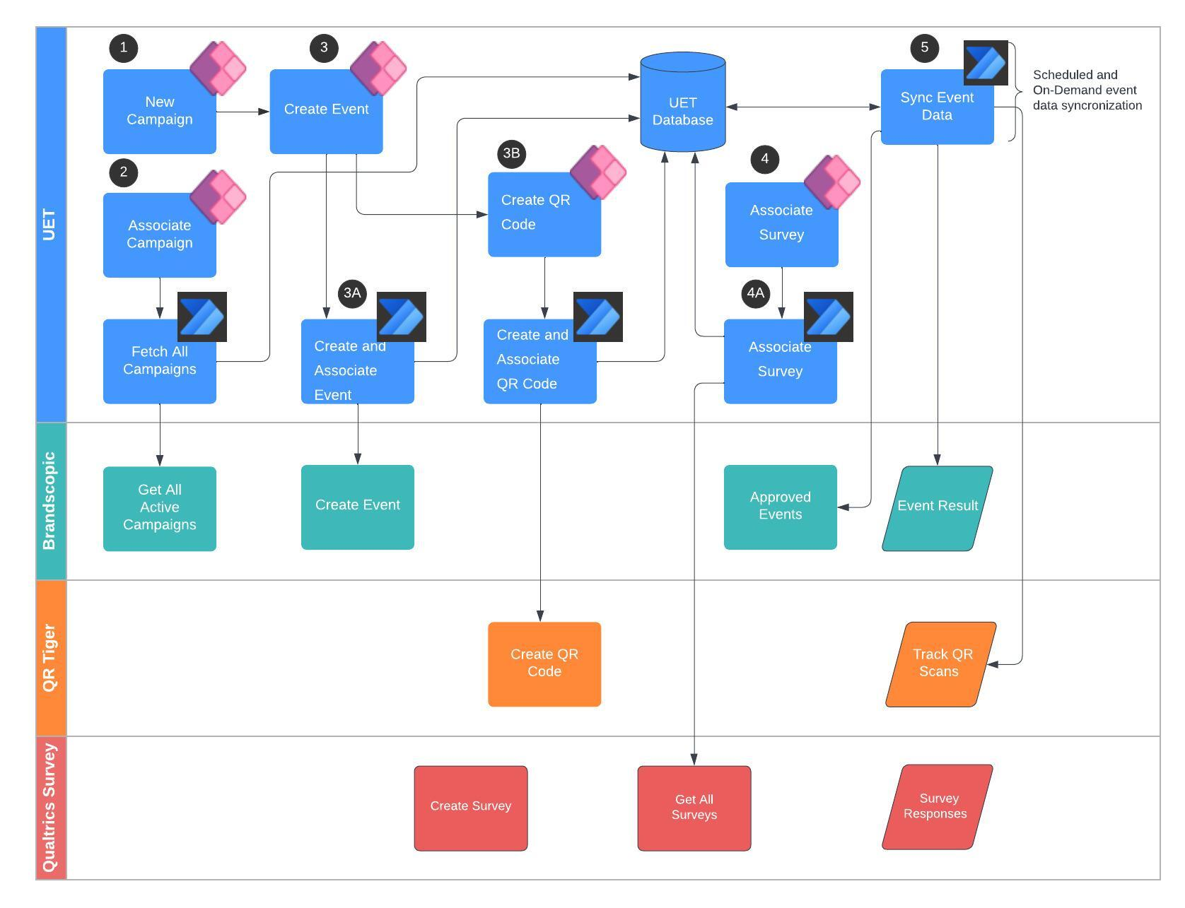
- The campaigns will be created in UET and will be manually linked with the campaign created in Brandscopic.
- Events created in UET will be automatically created in Brandscopic, and the event id from Brandscopic will be linked to the UET event id in the UET database.
  - This will be achieved through integration with Brandscopic API using Azure Function Apps.
- The UET system will utilize QR Tiger APIs to create a QR code. Upon submission of the QR data, the system will automatically generate the QR code through QR Tiger and map it in the UET database.
  - The integration with QR Tiger API will be established by using Azure Function App.
- The Surveys created in Qualtrics System will be mapped into the UET database.
  - The integration with Qualtrics Survey API will be established by using Azure Function App.
- To import post-event metrics into the UET database, we will utilize Azure integration services. The data from Brandscopic and QR Tiger will be synced at regular intervals `\through scheduled functions and with an on-demand data sync API developed within UET.

7 Data Dictionary:
LQA | Loop qual attempts
LQS | Loop qual success
VZ | Verizon
BL | Business Lead
Campaigns | The master event as per Brandscopic

